COURIER –
- Disarticulated Tissue and Full Thickness Skin
  - Monday – Thursday until 3 pm – FedEx Priority
  - Thursday at 3 pm – Sunday at 3 pm – Quick Courier
- En Bloc (Joint Restoration / Juvenile Knee / Specialty Graft)
  - Quick Courier

Cultures will be shipped with the tissue regardless of the method.

The following outlines the packaging and shipping procedures for AlloSource:

- AlloSource Tissue Packaging

  - AlloSource utilizes three shippers to ship their tissue:

  - Large – Should be used for MS or Skin tissue. Two shippers are suitable to be used when leg en bloc or knee en bloc recovery occurs.

  - Medium – Should be used for skin tissue.

  - Small – Should be utilized for juvenile knee tissue.

  - Obtain the appropriate AlloSoSrce shipper and ensure an AlloSource Shipping Label adheres to the box. Follow instructions in section 2 AlloSource MTB Viable Cell Restriction Guide on how to properly fill out the AlloSource Shipping Label.

  - Place a large clear bag in the shipping container.

  - Place a minimum of 40 pounds of ice, and a maximum of 48 pounds of ice into the shipping container.

  - Split the ice into two large plastic bags, zip tie shut using the s-tie technique, and place one bag flat inside the clear liner.

  - Check each tissue label for accuracy verifying the DNA donor number and tissue type while placing all tissues into a large clear bag. Once all tissues are in the bag, zip tie shut using the s-tie technique.

  - Place packaged tissues inside the cooler inside the clear liner on top of the existing bag of ice.

  - Place the remaining bag of bagged ice inside the cooler on top of the tissue.

  - Close and seal the clear liner bag enclosing the bottom ice bag, the tissue, and the top ice bag.

  - MS cultures will be placed inside an AlloSource-provided yellow bag and inside the shipper, on the outside of the clear liner.

Note: In some instances, the shipper may not have enough room to allow for 40 - 48 pounds of ice due to the size and number of recovered tissues. Be sure to use enough ice to maintain tissue during shipping. Multiple coolers and / or shipping containers can be used if needed. If more are used, they must be labeled “1 of 2” and “2 of 2”.

  - The s-tied bag of cultures will be placed outside the clear liner.

  - Place the lid on the shipping container.

  - Attach DP-TD10 Attachment I – Quarantine – Human Tissue Label on the outside of the Styrofoam cooler lid.

  - Attach the Yellow sticker indicating that cultures are located inside the shipping container to the top of the Styrofoam lid. The culture requisition forms should be placed in a ziplock bag and attached to this sticker on top of the lid.

  - Place the forms stated under DP-TD10 Attachment V – Tissue Recovery Shipping Paperwork Reference Guide into a large manila envelope stamped with the DP-TD10 Attachment II – Donor Records Stamp inside a zip lock bag on the top of the container.

  - Secure the cardboard box and arrange for shipment. Fill out the Tissue Green Shipping Label with the information known.

  - AlloSource Juveline Knee Tissue Packaging

    - Juvenile Knee tissue should utilize the small AlloSource shipper.

    - Place a clear plastic liner inside the shipping container.

    - Place the packaged Juvenile Knee tissue inside the liner bag and surround it with loose wet ice until the shipper is full.

    - Secure the liner with an s-tie.

    - Place the lid on the shipping container.

    - Attach DP-TD10 Attachment I – Quarantine – Human Tissue Label on the outside of the Styrofoam cooler lid.

    - Secure the cardboard box and arrange for shipment. Fill out the Tissue Green Shipping Label with the information known.

- AlloSource MTB Viable Cell Restriction Guide

  - Following the packaging of musculoskeletal tissue, the team needs to assess whether the recovered AlloSource MS Donor qualifies as a Cell Restriction Donor. If the criteria are met, the Yellow AlloSource Shipping Sticker must indicate a “Yes” in the Viable Cell Restriction box. If none of the below criteria are met in 2.2 the “No” box should be checked for “Viable Cell Restriction”. Resources like the Donor Risk Assessment Interview and Medical Record Review should be utilized in making this determination.

  - Document the Donor ID in the space provided that states “Enter Donor Number Here”

If Donor Has 1 Condition Below = Viable Cell Restriction
Condition | Link | Musculoskeletal
Donor is > 65years old |  | Viable Cell Restriction
Travel within the past 2 years, traveled for  ≥3months cumulative or immigrated from a country with most current available tuberculosis incidence of ≥20 (rate per 100, 000 population) | See Link below in Blue Box | Viable Cell Restriction
Exposure to an individual with tuberculosis disease within  the past 2 years |  | Viable Cell Restriction
(latent) tuberculosis infection > 2 years ago (i.e., positive TB  test > 2 years ago) |  | Viable Cell Restriction
Homelessness  Resided in a homeless shelter or a congregate setting in the past 2 years |  | Viable Cell Restriction
Incarceration in the past 2 years |  | Viable Cell Restriction
End Stage Renal Disease ([Chronic Kidney Disease (CKD)  5]) with or without dialysis |  | Viable Cell Restriction
Who have received solid organ transplant |  | Viable Cell Restriction
One Exposure Risk Factor and One Reactivation Risk Factor  (See Purple Chart Below) | Chart Below | Viable Cell Restriction

If 1 exposure and 1 reactivation = Viable Cell Restriction |  | Travel Website Information: Once clicking on the WHO link. Select the country of visit. Then hover your cursor over the "Estimated TB incidence Rate" Chart and move cursor to most recent year to the right.  WHO LINK
Exsposure Risk Factor | Reactivation Risk Factor
Birth, travel, or residence ≥ 3 months cumulative in a country with most current available tuberculosis incidence of ≥ 20 (rate per 100,000 population) that occurred > 2  years ago | with advanced kidney disease, pre dialysis— otherwise known as CKD Stage 4, GFR < 30
Ever experienced homelessness and were housed in  shelters or other congregate settings > 2 years ago | with diabetes mellitus | 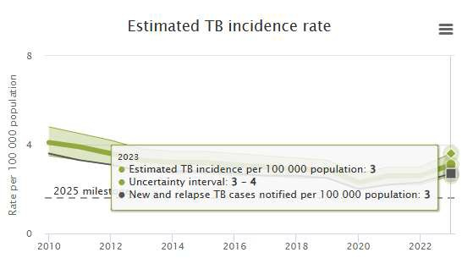
Have been incarcerated ≥ 2 years ago | with cirrhosis or alcoholic liver disease
Have had exposure to an individual with tuberculosis  disease > 2 years ago | with alcohol use disorder/ excessive or heavy  alcohol use
 | who use immunosuppressive medications
Example: Donor who was in jail 20 years ago for one day and has a history of diabetes mellitus. This donor would be Viable Cell Restriction for Musculoskeletal.

  - From – Document the Organization, address, city, state, zip code and phone number on the sticker provided.

- Arrange Tissue Shipment

  - Contact Quick Courier via web address and provide the necessary data to arrange for shipment. Utilize the shared Tissue Team 1password to log in.

  - Under the Shipping section, go to Place Individual Orders.

  - Select 10826 – AlloSource and click on select.

  - Fill in the required data and select next.

  - The system will auto-populate the pick-up and delivery sections. If it does not, use the address book button to the right and click on Donor Network of AZ for pick-up, and AlloSource for delivery.

  - Do not change the shipment ready time. The check box for best possible delivery (ASAP) should be auto-marked, do not uncheck this box or fill in a time.

  - Add in number of Pieces (boxes) and Total Weight.

  - Under Commodity, select Tissue on Wet Ice.

  - Under Shipper Reference Number, add in the DNA# and click “next” at the bottom.

  - Review all information to ensure accuracy. Click Submit Order. Print waybill and place it on the tissue box.

  - Sign tissue into the Sally Port log and place tissue in / on the appropriate bay / shelf.

  - If shipping via FedEx Courier- utilize a pre-printed FedEx waybill/sticker.

  - Add the DNA number to the waybill and attach to the top of the box.

  - Tissue designated for FedEx will go on the FedEx outgoing shelf in the Sally Port.

- Offline Quick Shipping

  - If Quick’s online portal is down, follow the steps below to ship tissue.

  - Call Quick Courier at 1-800-473-4673.

  - A call menu will be available, press 1 to place an order for pick-up.

  - You will be promoted to another dial menu which you will press 1 for domestic shipment.

  - Let the associate know you need to ship tissue to AlloSource in Centennial, Colorado. Give them the account number: 10826.

  - Delivery address for AlloSource: 6278 South Troy Circle Centennial, CO 80111.

  - The associate will ask a few questions regarding the order.

  - A waybill number will be given at the end of the call which will be recorded on the Tissue Sent by Type page.

  - Once the order is complete and before disconnecting the phone, ask the associate to send the waybill to Recovery-Phoenix@dnaz.org.

  - Print the waybill from the email and place it on top of the tissue box.

  - Sign tissue into the Sally Port log and place tissue in / on the appropriate bay / shelf.

AlloSource Culture Sticker – For reference only. Refer to Q-Pulse for the most up-to-date version.



AlloSource Quarantine Tissue Label - For reference only. May not be the most up-to-date version. Refer to Q Pulse for the most up-to-date version.
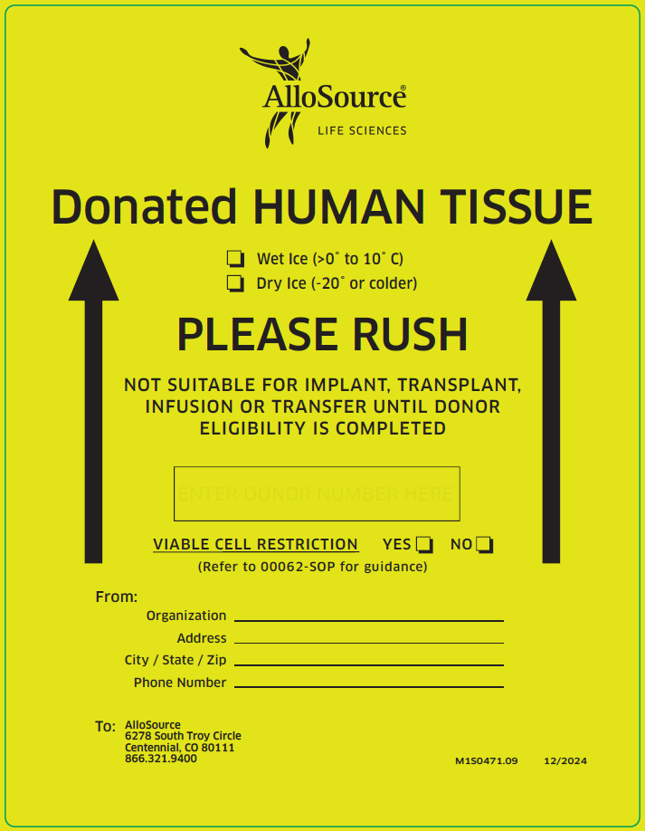

Tissue Green Shipping Label - For reference only. May not be the most up-to-date version. Refer to Q Pulse for the most up-to-date version.



