COURIER for Tissue – Validated Delivery Solutions
COURIER for Cultures – FedEx and Validated Delivery Solutions

The following outlines the packaging and shipping procedures for PTT:

- Pinnacle Transplant Technologies (PTT) Musculoskeletal Tissue:

  - Place a plastic liner into the insulated shipper and insert the packaged tissue.

  - Place approximately 15 - 20 pounds of wet ice in the bottom of a large plastic bag.

  - Place the tissue recovered from the left side, each part wrapped, taped, and labeled properly, in a large plastic bag.

  - Attach the tie and label the outside of the bag with the left and Donor ID #.

  - Place the large plastic bag of tissue from the left side in the insulated shipping container.

  - Place Tissue recovered from the right side, each part wrapped, taped, and labeled properly in that large plastic bag.

  - Attach the tie and label the outside of the bag with the right and Donor ID #.

  - Place the large plastic bag of tissue from the Right side in the insulated shipping container.

  - Place 15 – 20 pounds of wet ice in the bottom of a large plastic bag.

Note: In some instances, there may not be enough room in the shipper to allow for 30 - 40 pounds of ice due to the size and number of recovered tissues. Be sure to use enough ice to maintain tissue during shipping. Multiple coolers and / or shipping containers can be used if needed. If more are used, they need to be labeled “1 of 2” and “2 of 2”.

  - Place the large plastic bag of ice at the top of the validated insulated shipping container.

  - Close and attach the tie to the liner bag.

  - Place a Styrofoam lid on top to seal the insulated shipping container.

  - Attach DP-TD10 Attachment I – Quarantine Human Tissue Label on the outside of the Styrofoam lid.

  - DP-TD10 Attachment V – Tissue Recovery Shipping Paperwork will be emailed to Pinnacle Transplant Technologies utilizing email address: DonorIntake@pinnacletransplant.com

  - Attach the PTT Quarantine Tissue Label (below) to the sides of the cardboard box and select the appropriate tissue types being shipped to PTT.

  - Secure the cardboard box and arrange for shipment. Fill out the Tissue Green Shipping Label with information known.

- Pinnacle Transplant Technologies (PTT) Culture packaging:

Note: Cultures will primarily be shipped Monday – Friday using Fed Ex. They will be placed in a secured refrigerated environment until the time of shipment.

  - All labeled culture specimens will be placed into a small red biohazard bag and / or Ziploc bag.

  - Obtain a VRL Eurofins culture shipper.

  - Ensure all culture tubes are labeled and place each individual culture tube in a sleeve of a swab shuttle.

  - Place a VRL accession label from the requisition form and affix it to the outside of the swab shuttle pouch.

  - Wrap the samples with the ambient gel pack at the bottom of the shipper.

Note: The gel pack should remain at ambient temperature.

  - Fill a small bag that is labeled “wet ice” with wet ice and seal. Place the small bag with the wet ice along with absorbent material in a larger bag and seal.

  - Place the full bag on top of the ambient wrap.

  - Place the lid on the container.

    - Refrigerated culture tubes are viable for up to 7 days.

    - Non-refrigerated (ambient) culture tubes are viable for up to 4 days.

  - Complete the Culture Requisition Form provided as outlined in DP-TD01 Collection of Tissue Cultures and Biopsies.

  - Place the original requisition form in the donor chart.

  - Place the copies of the requisition form in the clear plastic sleeve and place them in the box inside the shipping bag provided.

  - Seal the shipping bag.

  - Secure the cardboard box and arrange for shipment. Fill out the Tissue Green Shipping Label with the information known.

- Arranging for Shipment

  - Tissue

    - Using a Validated Delivery Solutions pre-printed waybill contact VDS at 800-351-6451.

    - Let the associate know you need to make a shipping arrangement to Pinnacle Transplant Technologies using account number 3012.

    - The associate will ask you a series of questions regarding the shipment.

    - On the waybill document the DNA# under the Shipper’s Reference section.

    - Under contents: write Tissue on Wet Ice.

    - Add in the total pieces (boxes) and total weight.

    - Add your printed name and signature.

    - Add the Waybill/Job# to iTransplant under the Tissue Sent by Type page.

    - Sign tissue into the Sally Port log and place tissue in / on the appropriate bay / shelf.

  - Validated Delivery Solutions- No Waybill Shipping

    - If we do not have any physical waybills in-house, follow the steps below to ship tissue.

    - Call VDS at (800) 351-6451.

    - Let the associate know you need to ship tissue to Pinnacle Transplant Technologies in Phoenix, Arizona. Give them the account number: 3012.

    - Delivery address for Pinnacle: 1125 W. Pinnacle Peak Road Phoenix, AZ 85027.

    - The associate will ask a few questions regarding the order.

    - Once the order is complete and before disconnecting the phone, ask the associate to send the waybill to Recovery-Phoenix@dnaz.org.

    - Print the waybill from the email and place it on top of the tissue box.

    - Sign tissue into the Sally Port log and place tissue in / on the appropriate bay / shelf.

  - Cultures

    - Monday – Friday before 1500

Cultures will be sent out via Fed Ex and placed on the FedEx Outgoing shelf for normal pick up in the afternoon.

    - Friday after 1500 – Sunday

Cultures will be kept in a designated temperature-controlled refrigerator until Monday morning when the shipment will be arranged.

PTT Quarantine Tissue Label - For reference only. May not be the most up-to-date version. Refer to Q Pulse for the most up-to-date version.

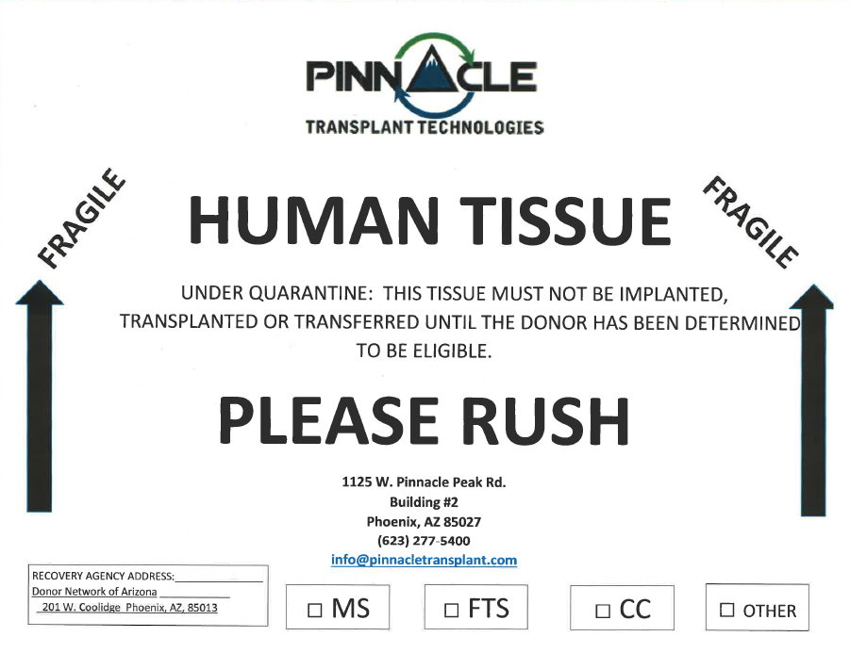

Tissue Green Shipping Label - For reference only. May not be the most up-to-date version. Refer to Q Pulse for the most up-to-date version.



